**PROJECT REPORT**

**1.INTRODUCTION:**

# 1.1. Project overview

This project centre’s on creating a visualization tool for analyzing **electric vehicle (EV)** performance-specifically focusing on battery charging time and driving range. These two factors are known hurdles in EV adoption, so the tool aims to deliver data-backed insights that help EV users optimize their experience.

# 1.2. Purpose

The primary purpose of this project is to empower electric vehicle (EV) users with datadriven insights into their vehicle’s performance—specifically charging efficiency and range prediction. By visualizing key metrics like battery capacity, charge time, and travel range, the tool helps users make smarter, more confident decisions about their EV usage. It also encourages energy-conscious driving habits through awareness and education.

**2. IDEATION PHASE:**

# 2.1 Problem Statement

Despite the growing adoption of electric vehicles (EVs), many users struggle with understanding how far they can travel on a charge and how long it will take to recharge their vehicle. Current EV dashboards often lack intuitive and detailed insights into battery health, charging efficiency, and real-time range predictions. This lack of transparency can lead to inefficient route planning, unexpected battery depletion, and user anxiety—commonly referred to as "range anxiety. "There is a pressing need for a user-friendly tool that visually presents essential EV performance data, enabling users to make informed decisions about charging habits and travel plans.

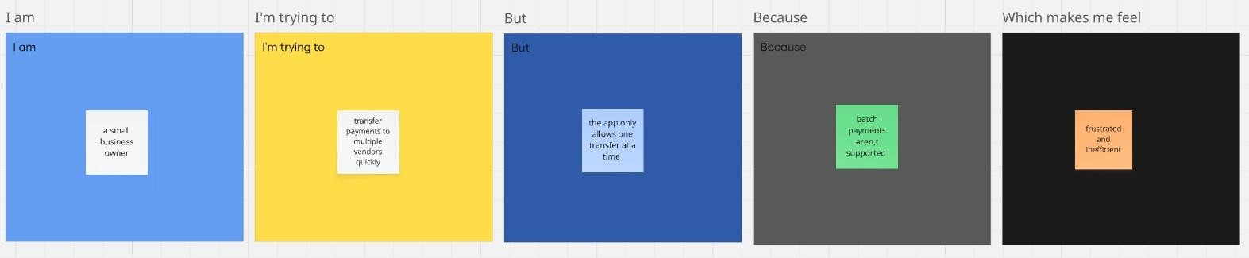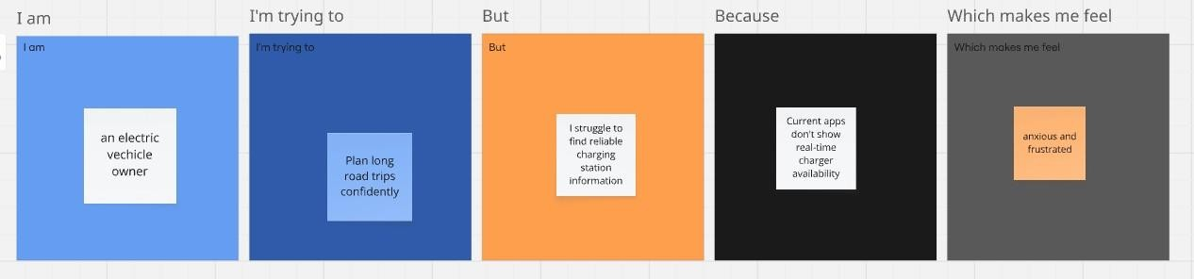

**2.2**



**Empathy Map Canvas**

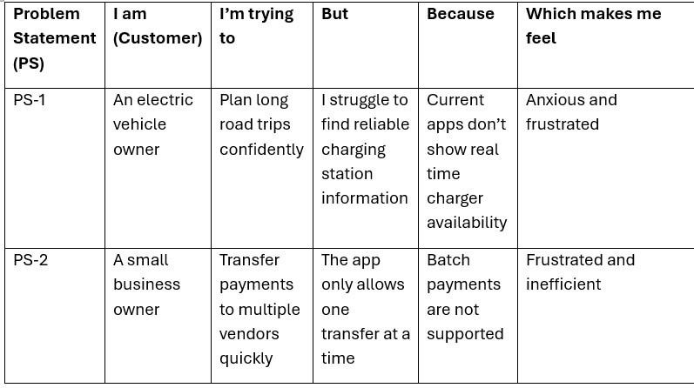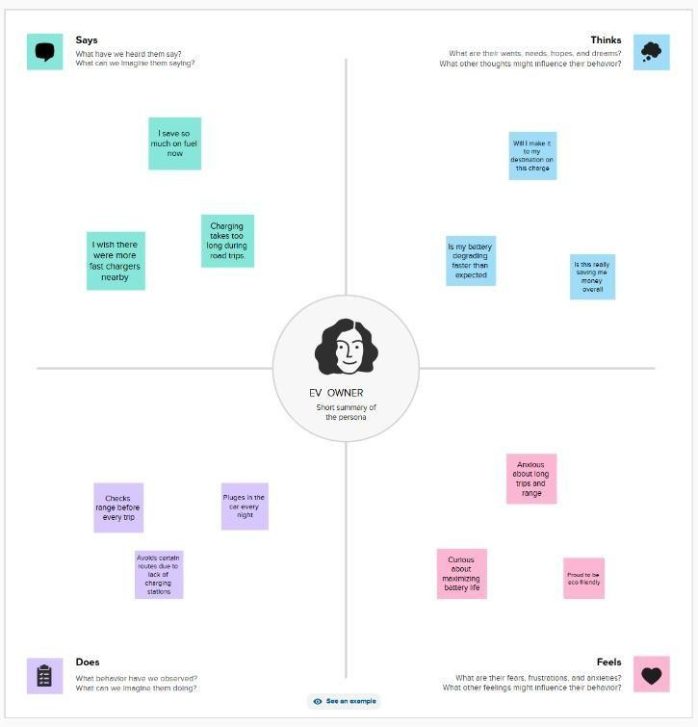

# 2.3 Brainstorming

Step-1: Team Gathering, Collaboration and Select the Problem Statement

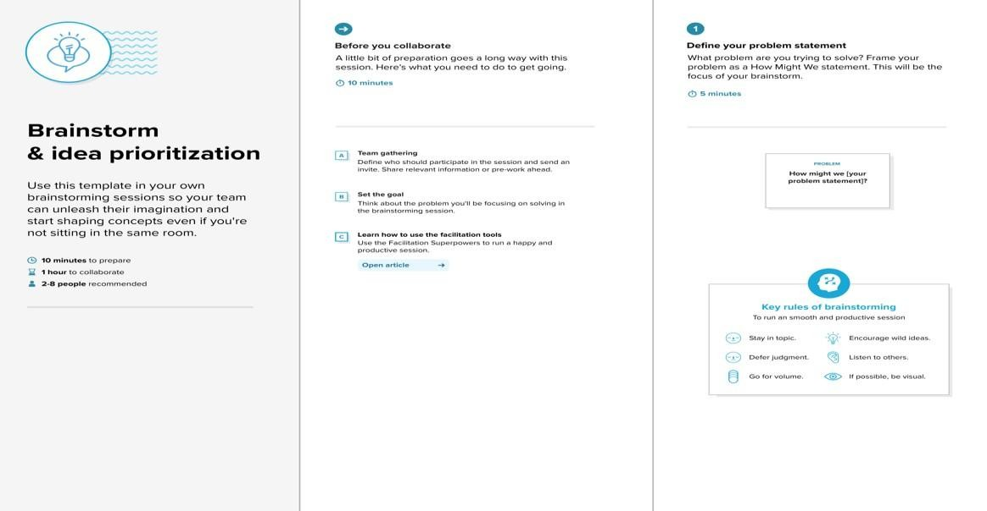

Step

-

2:

Brainstorm, Idea Listing and Grouping

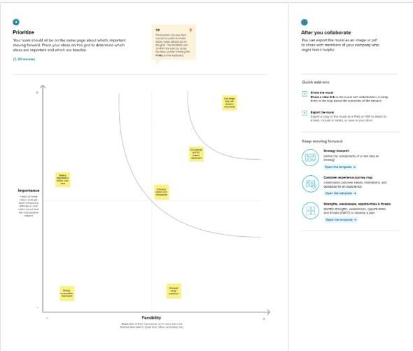

Step



-



3:



Idea Prioritization

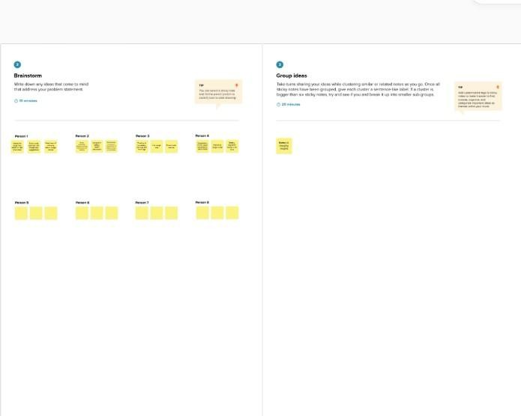

# 3. REQUIREMENT ANALYSIS

## 3.1 Customer Journey map

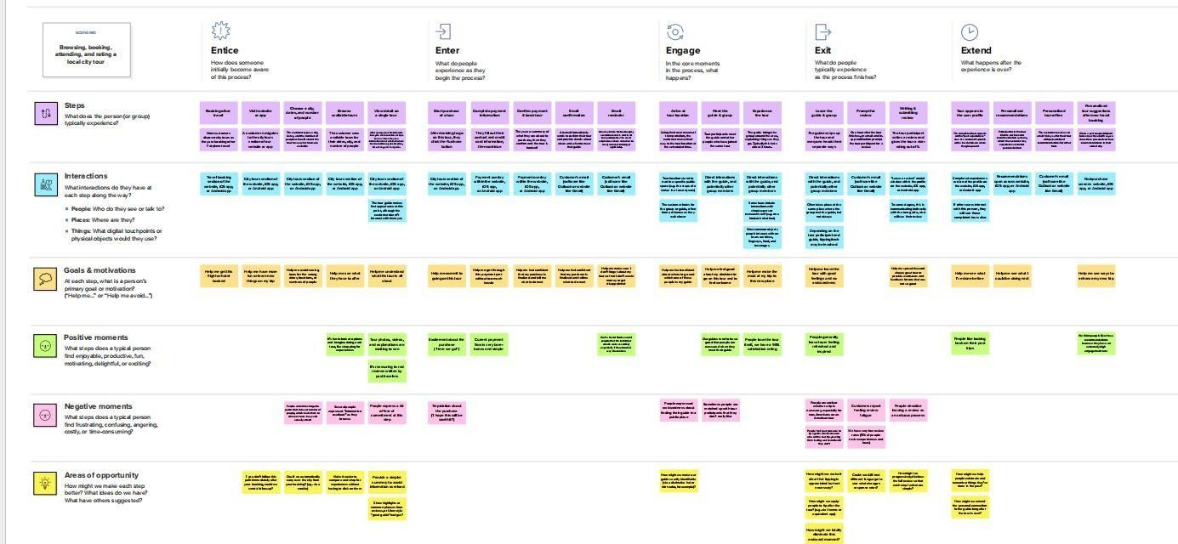

## 3.2 Solution Requirement

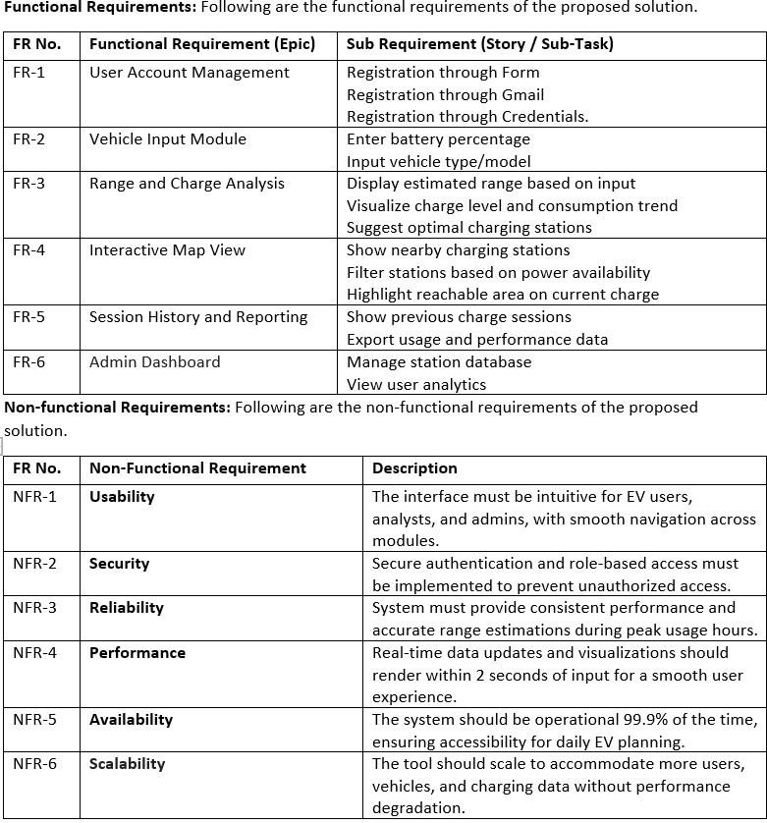

## 3.3 Data Flow Diagram

**3.4**

**Technology Stack**

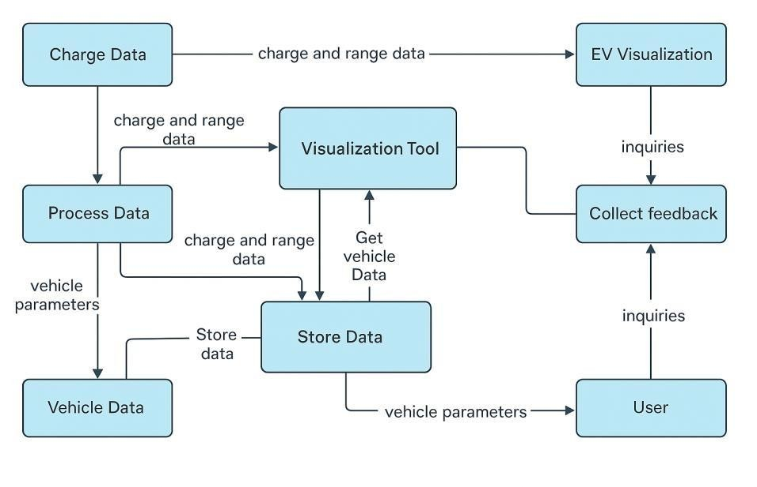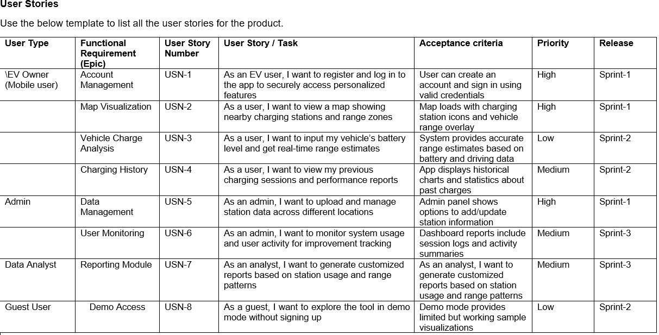

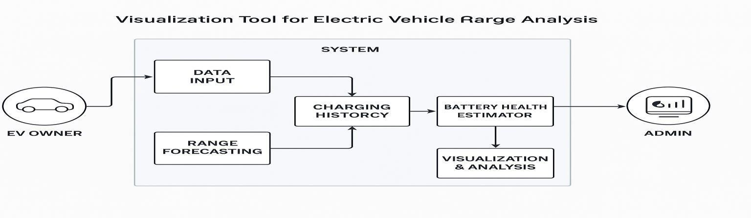

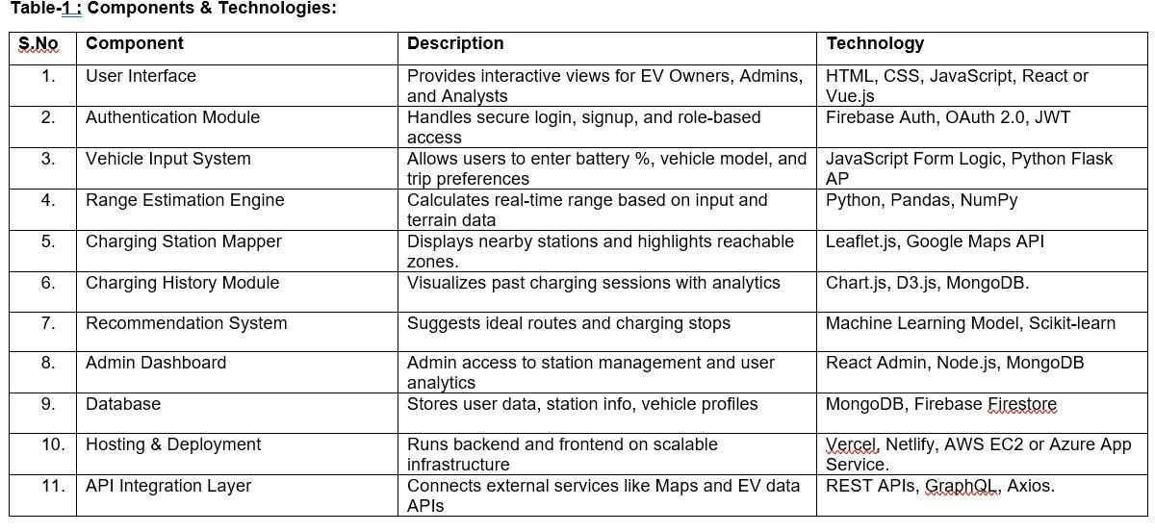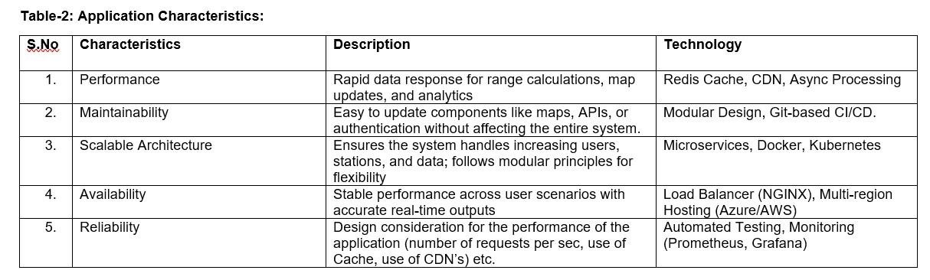

# 4. PROJECT DESIGN

## 4.1 Problem Solution Fit

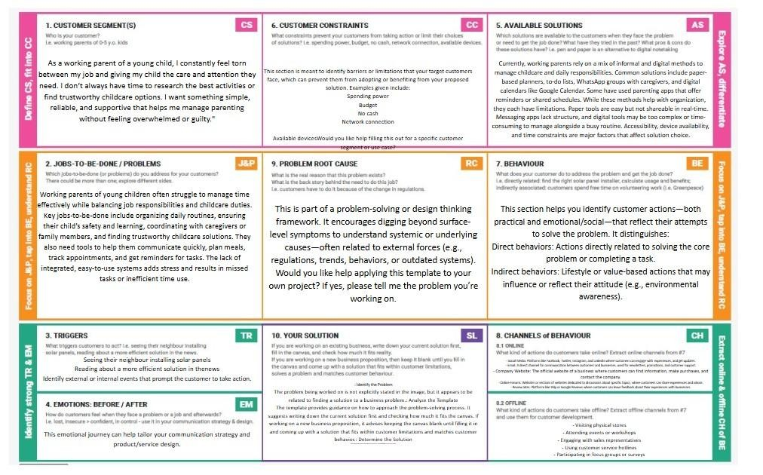

## 4.2 Proposed Solution

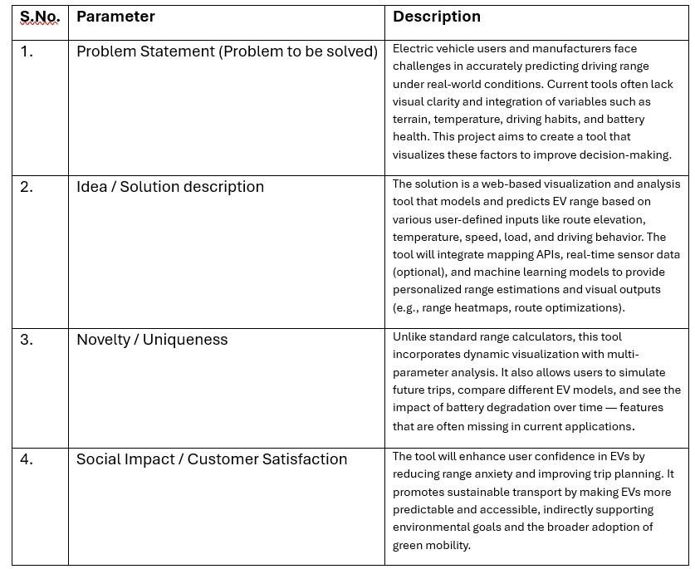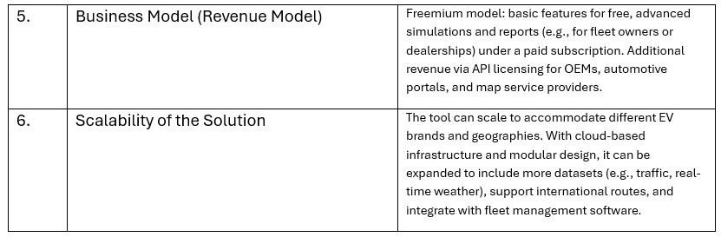

## 4.3 Solution Architecture

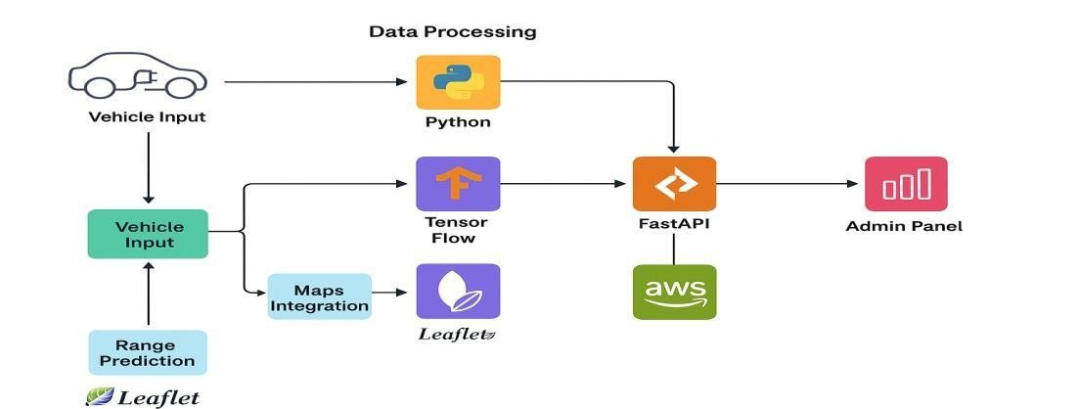

# 5. PROJECT PLANNING & SCHEDULING

## 5.1 Project Planning

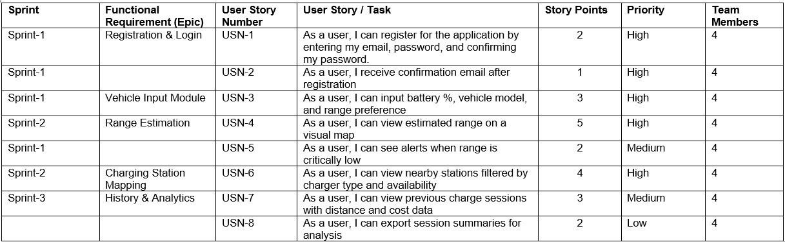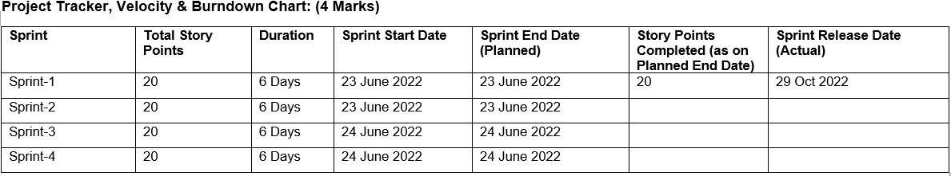

## 6. FUNCTIONAL AND PERFORMANCE TESTING

### 6.1 Performance Testing

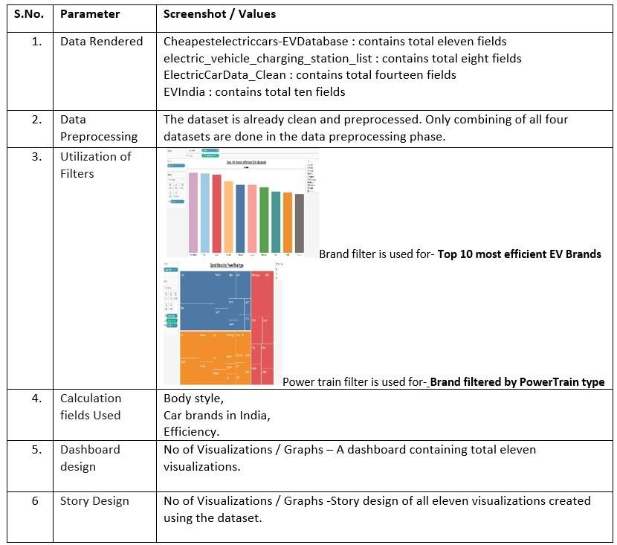

# 7. RESULTS

## 7.1 Output Screenshots

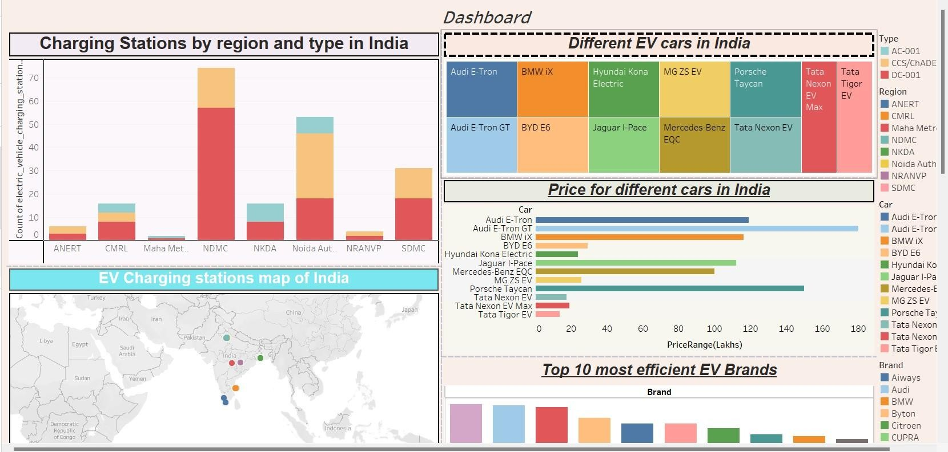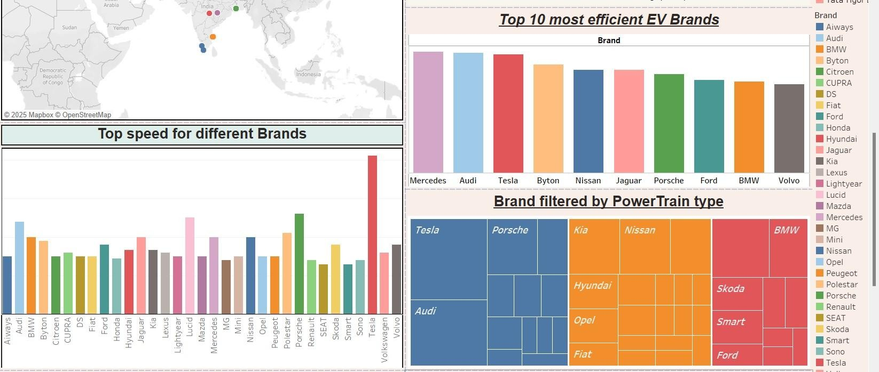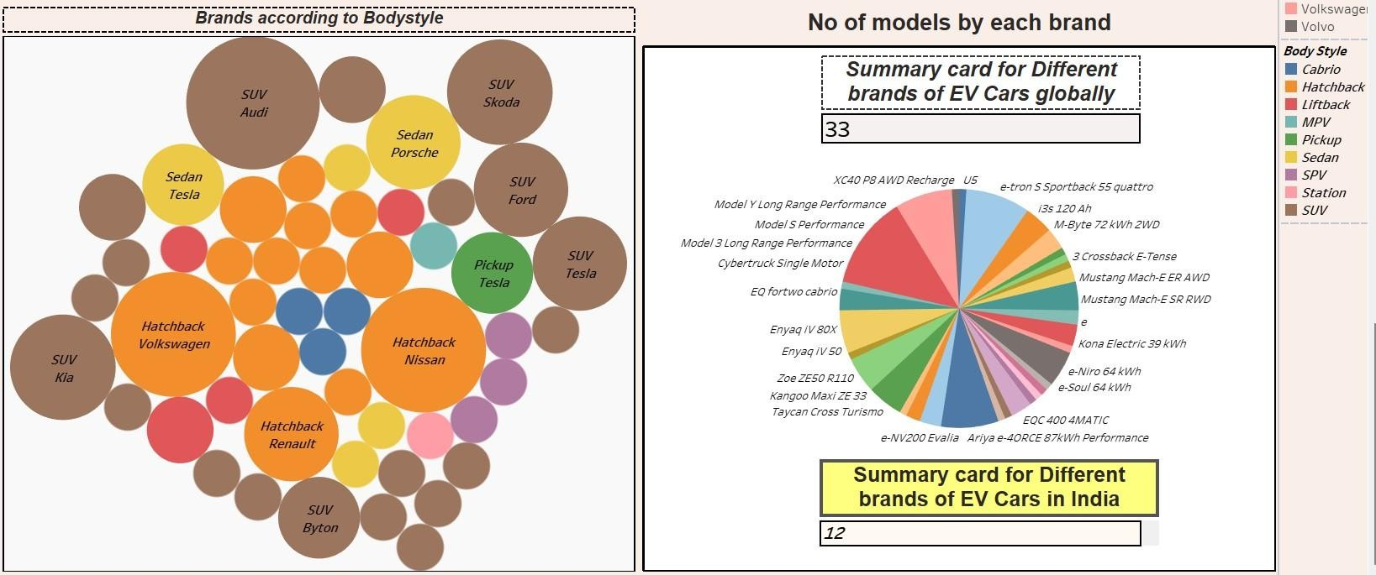

## 8. ADVANTAGES & DISADVANTAGES Advantages

* Enhanced User Awareness: Helps users understand charging behavior, energy consumption, and travel planning.
* Customizable Analysis: Allows EV owners to input specific vehicle data for tailored insights.
* Educational Utility: Promotes informed decision-making and environmental consciousness, especially if gamified.
* Accessible Visualization: Transforms complex battery and performance data into intuitive, visual formats.
* Potential for Expansion: Can be integrated with map APIs, real-time charging station data, and IoT inputs.

## Disadvantages

* Data Dependency: Accuracy relies heavily on the availability and quality of EVspecific data.
* Device Compatibility: May require optimization for different screen sizes or browser support.
* Scalability Limitations: Handling real-time data for numerous users simultaneously could strain server resources.
* Learning Curve: Users unfamiliar with data dashboards or EV tech may find the interface initially complex.

# 9. CONCLUSION

The EV Charge and Range Visualization Tool offers a practical solution to one of the most pressing concerns in electric vehicle adoption: understanding and managing battery performance. By transforming complex EV data into accessible visuals, this project empowers users to make confident, informed decisions about their charging habits and travel planning. With customization options, educational potential, and opportunities for future expansion, the tool represents a meaningful step toward enhancing the EV user experience and promoting sustainable mobility.

# 10. FUTURE SCOPE

The EV Charge and Range Visualization Tool has strong potential for further development and innovation. Here are some directions to expand its scope:

* Real-time Data Integration: Connect with live data sources from EVs or IoT charging stations to offer dynamic, up-to-date insights.
* Route Planning with Charging Stops: Incorporate map APIs to suggest optimal travel routes based on battery range and nearest charging stations.
* AI-Powered Predictions: Use machine learning to forecast battery degradation, energy consumption patterns, and charging time under varying conditions.
* Mobile App Version: Expand accessibility by developing a lightweight, responsive mobile version for on-the-go users.
* Community-Driven Insights: Allow users to share charging experiences, station reviews, and efficiency tips, building a knowledge-sharing ecosystem.
* Gamification Elements: Introduce interactive missions, eco-badges, or progress tracking to boost user engagement and learning, especially in educational contexts.

# 11. APPENDIX

Dataset Link - [https://drive.google.com/drive/folders/1Rkzdks6Us1Uq2SRB4nxMAb83jN5bpHll? usp=sharing](https://drive.google.com/drive/folders/1Rkzdks6Us1Uq2SRB4nxMAb83jN5bpHll?usp=sharing)  
GitHub – <https://github.com/raghurammanikanta/visualization>[-tool-for-electricvehicle-charge-and-range-analysis](https://github.com/raghurammanikanta/visualization-tool-for-electric-vehicle-charge-and-range-analysis)

Project Demo Link-

https://drive.google.com/file/d/1FpLxxSl9KugX8DTSUfndlzhrhXHgSTN8/view?usp=drive_link